Ref: Uzbekistan tour Date: 05.06.2025

Uzbekistan tour Tashkent-Samarkand-Tashkent packaging

Day | Detailed itinerary
D1 | 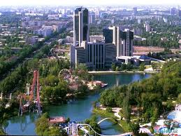  TASHKENT Local guide  Arrival in Tashkent. Transfer to Hotel Check-in and have arrest.  Overnight in Tashkent.  Meals: -
D2 | 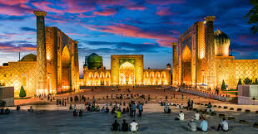  TASHKENT-SAMARKAND-TASHKENT speedy train  Breakfast at hotel.  Early in the morning, transfer to the railway station to board the high-speed Afrosiyob train to Samarkand – the legendary city of blue domes and anci ent wonders.  Upon arrival, a full-day guided city tour will begin, exploring the timeless treasures of Samarkand. Highlights include:  - Registan Square – the heart of ancient Samarkand and one of the most iconic sights in Central Asia, framed by the stunning madrasahs of Ulughbek, Sher-Dor, and Tilla-Kari.  - Gur-e-Amir Mausoleum – the majestic final resting place of Tamerlane (Amir Timur), adorned with intricate tilework and a soaring dome.  - Bibi-Khanym Mosque – once one of the largest mosques in the Islamic world, built by Timur in honor of his beloved wife.  - Siyob Bazaar – a lively local market offering fresh produce, traditional sweets, and souvenirs.  - Shah-i-Zinda Necropolis – a sacred complex of mausoleums with vibrant turquoise mosaics and rich spiritual atmosphere. If time permits, Konigil village also includedAfter a full day of exploration,transfer to train station in order to returning Tashkent.  Meals: Breakfast at hotel.

All rates in USD (per person)
Group size | DBL/TWIN shared with breakfast meals
2pax | 426
4-5 pax | 316
10-14+1FOC | 299
15-19+1FOC | 284
20-24+1FOC | 272
Single supplement | 38

Proposed hotels:
City | Nights | Hotels
Tashkent | 1 | Mirzo boutique or similar

Included:
- Accommodation (DBL/TWIN shared)
- Meals: Daily Breakfasts
- Entrance fees and porterage at hotels
- Trainfares with economy class
- Local English-speaking guide
- Map of Uzbekistan
- Mineral water (0.5 L daily)
- A/C Transport: Minibus 20-30 seats (11-20 pax), Minivan 5-9 seats (3-6 pax), Sedan Car (2 pax).
- All taxes

Not included: alcoholic/nonalcoholic beverages, personal expenses, tips, gratuities, and any other services, which is not mentioned in the program.

IMPORTANT:
- If a place of visit is closed to visitors, it will be replaced with an alternative. During major events, accommodation may be changed and replaced with a similar category
- Sequence of itinerary and hotels given is subject to changes without prior notice.
- Hotel accommodation is subject to availability. No reservations are made before confirmation received from client. If mentioned hotels are not available, we will substitute them with other hotels of similar class.

Payment:
- Tour payment should be made not less than 15 days prior to tourist group arrival to our bank account as per invoice.

Cancellation fees:
- Cancellation prior 45 days – No charges apply
- Cancellation prior 20 days – 50% charge of the tour price
- Cancellation prior 10 days – 100% charge of the tour price

